**Region Management Subsystem Functional Requirements, v0.3**

**Author: Josh Trimm**

**Edited by Phil Pfeiffer**

**Last Updated 12 September 2021**

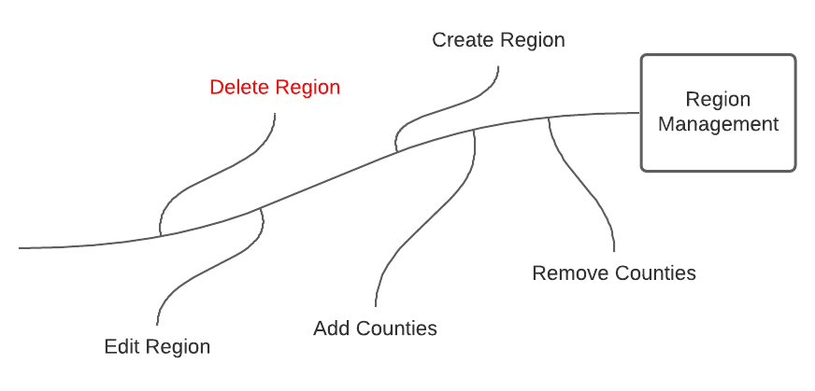

# Description

The Region Management system will allow users to create, define, and describe custom regions by adding counties that are geographically close together.

# Function Requirements

1. The system shall allow the Admin and Cartographers to add new regions to the collection of saved regions.
   1. A region’s creator must assign that region a name that differs from all other named regions in the collection.
   2. A region’s creator must populate that region with counties drawn from a list of counties that are named in one of the uploaded CHR datasets.
      1. Each region must contain at least two counties.
   3. A region’s creator may associate that region with a description.
2. The system shall allow the editing of saved regions
   1. For those regions they have created, Cartographers shall be allowed to remove or add counties, alter the description, or rename the region’s title.
   2. Admins shall be allowed to edit any region, by removing or adding counties, altering the description, or renaming the region’s title.
3. The system shall allow Cartographers and Admins to retrieve the names of all predefined regions created by all users.
4. The system shall track when the region was created, last updated, and who created it.
5. The system shall allow the deletion of regions.
   1. Cartographers shall be allowed to delete those regions that they have created.
   2. Admins shall be allowed to delete any region.
   3. When a user asks to delete a region which they have permission to delete,
      1. The system shall notify the user of any regions that are being referenced by a saved chart.
      2. The system shall ask the user to confirm the deletion.
      3. The system shall disable all the charts that were using the region after the region is deleted.

# County and Year Association for Counties Defined in a Region

Potentially, each year county names, FIPS codes, and data points can change. This creates a problem when defining a *Region of Counties* to use for a chart. If a county is nonexistent from a year that a data point is being used, this can create charting errors.

To address this situation, while still allowing any CSV year to be associated with any county year, if a county is not in a specific year, the system will treat it as having no data. This will eliminate the use of tracking what year had specific counties across the United States.

In the case that a county was renamed or merged into another county, the region creator would need to add the old and new county. This would offset the chance of having no data while choosing a specific CSV year.